

The Interim Report for the second year
Electrical & Electronic Engineering group project
(Module name: EE2-PRJ E2 Project)

Portable Battery operated Atmospheric Water Generator

Project supervisor: Dr. Balarko Chaudhuri
Project group member:
Name | CID
Heran Zhang | 01054578
Zihao Zhang | 01117815
Qirui Peng | 01044219
Gregory Fil | 00943128
Nicholas Yik Ming Ting | 01041132
Un Kei Leong | 01057638
Shaun Christopher Price | 01078017

Date of submission: 8th February

Contents Page
1
Contents Page 2
Abstract 3
1. Introduction 4
Existing products 4
Similar products currently in development 4
2. Design Specification 5
a) Portability 5
b) Generate water by condensing air moisture 5
c) Battery Operated 5
d) Integrated Filtering 5
e) Low cost 5
f) Internal Components 5
g) Health Safety 5
h) Electrical Safety 5
i) User-friendly 5
3. Concept Design 6
3.1 Design 1 6
Cooling Mechanism 6
Heat sinks 7
Cost estimation 7
3.2 Design 2 7
General Description 7
Cooling Mechanism 8
Cost estimation 8
3.3 Comparison of both designs 8
Budget and further cost: 8
4. Discussion 9
4.1 Cooling and Thermoelectric Devices 9
Seebeck Effect: 9
Thomson Effect 9
Peltier Effect 9
4.2 Condensation 10
4.3 Water collection methods: 10
4.4 Water purity and possible contamination from metals 10
4.5 Does aluminium affect general health? 11
5. Progress to Date 11
Test results 11
6. Future work 12
7. References 12
Appendix 13

Abstract
Water is vital to every human, animal and plant on Earth. However, only around 2.5% (Water Distribution on Earth, 2016) of all water found on earth is drinkable for humans and animals due to pollutants and impurities such as salt, sewage and bacteria.
As a possible alternative water resource, this project aims to produce a portable, battery operated device attached to a container, which is capable of filling itself by condensing airborne moisture using heat sinks and a Peltier cooling module. Drinkable water can be achieved by purifying the collected water.
The proposed product is designed for people who reside in areas where droughts are common or where water is contaminated and dangerous to drink. The device could also be adapted to be used in sports such as cycling and hiking, where running out of water is a real danger and a clean, reliable source of drinking water could save a life.
To successfully extract water from the air, currently viable ways of extracting water from air are considered. These include methods such as those used by dehumidifiers and existing industrial-scale water generators. Once a working large scale proof of concept has been created, the focus will shift to downsizing the device. To improve the chances of producing water, different condensation conditions will be considered.

Introduction
The area addressed is water generation, particularly the generation of safe-to-drink water. The shortage of fresh, drinkable water has been a major issue for many years, and with the ever-growing population it is becoming even more of a problem. Countries such as Africa and China regularly have severe water shortages, resulting in the drinking of unclean, bacteria ridden water which can lead to diseases such as Cholera and Hepatitis, which can lead to death (Waterborne Diseases, 2014).
The goal is to create a device that can supply a reliable source of drinking water in poverty stricken areas where there is a possibility of running out of water, being in danger of dehydration and having to resort to drinking unclean water.
The device should be priced such that the government would consider issuing them to citizens providing them the ability to generate their own water. The device could also be released into the sports industry, aimed at hikers and cyclists.

During the research phase, existing products and similar products to our device that are currently in development are compared. Details on existing products can be found in the appendix, but a brief overview of what was discovered is summarised below:

Existing products
- Are very large and require mains power to operate.
- Are popular in large office buildings as they provide potentially unlimited drinking water without the employer having to pay to refill water drums.
- Pay for themselves many times over during their lifetime.

Similar products currently in development
- Water bottle sized devices are being made which are either solar powered or work with physical movement.
- The solar powered device is similar to the proposed device but uses large solar panels to generate the power required for it to operate.
- Whilst being more environmentally friendly, this means that the user must carry around the solar panels, which can be inconvenient, and means that it cannot used at night.
- The device that works through movement is designed to attach to the frame of a bicycle. When the user is riding the bike, the airflow over the device is utilized to generate water.
(See Appendix for more detailed information on both existing and currently in development products)

Design Specification

Portability
The device should be designed to fit a water container, initially a square container but with the aim to be using a conventional cylindrical container. The device is designed to be held when in use and small when not in use, so portability is very important. It may also prove to be the most difficult part of the design specification to implement within time and budget constraints.

Generate water by condensing air moisture
The device should be able to generate approximately 0.5 litres of drinkable water. It should be able to achieve this within a reasonable time frame; the expected time for the prototype will also be considerably higher compared to if the product had been made with custom parts and more time was allocated to the design of the device. It is likely that the prototype must be run overnight. Larger containers would allow for more space in the generator itself but will sacrifice portability and will increase the time needed to fill the container.

Battery Operated
Conventional batteries are needed to power the device, increasing portability and allowing operation in rural areas where an electricity supply may not be available. If the time and budget permits, rechargeable batteries, such as those found in Bboxx, can be created.

Integrated Filtering
The end water must be purified and filtered before it can be safe to drink, which can be measured by spectrum analysis during the testing phase. This can be done using a simple filter and/or integration of water purification tablets.

Low cost
Research (See Appendix) shows that the prices of existing products are so high (£640-£3200) that the general public are not able to afford it. The finished device must be significantly cheaper (£30 - £80).

Internal Components
Provided that the device is operational, further design and production requires a simple circuit. In addition, the component arrangement need not be complex to allow for cost effective large scale production.

Health Safety
Water purity must be maintained to avoid damaging user health. In addition, contact between the internal circuitry and the water must be avoided.

Electrical Safety
Large currents (1-2 Amps) but low voltages (3-5 Volts) can become dangerous when in contact with water, particularly in the presence of salt.

User-friendly
Clear instruction needs to be provided for the user. The flask should be easy to disassemble for filter changing, battery changing or regular rinsing.

Concept Design
Following from this specification, the following design concept was proposed.

The device will operate by using a cooling module to cool a heat sink to a desired temperature in order to allow condensation to begin building up on the cold heat sink. A fan will then circulate air across the heat sink, accelerating the accumulation of condensation whilst also cooling the cold heat sink further to increase power efficiency.

The condensation will then be collected and passed through a filter to remove any impurities before being drinkable.
A block diagram of the proposed device can be found in the appendix.

Discussed below are two concept designs.

3.1 Design 1
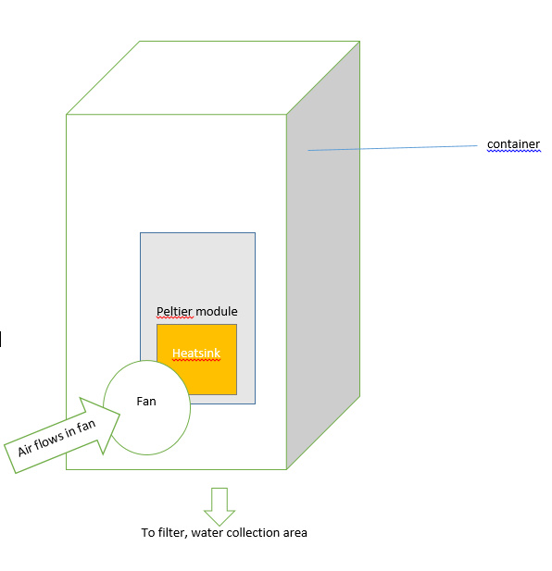
Figure 1 - Diagram of Peltier, heat sink, fan
Details on the Peltier module and selection of materials can be found in section 4.

Cooling Mechanism
A Peltier module creates a temperature difference across 2 sides. When a current is passed through the module, heat is extracted from the cold side and passed to the other side.
To utilise the Peltier module, it was proposed that the hot end of the Peltier module should be attached to a large fan assisted heat sink to dissipate the heat extracted from the cold side of the module.

Several large but thin copper or aluminium layers will be attached to the cold side of the Peltier module to increase the cold surface area to increase the rate of condensation. In addition to this, to ensure that the water flows downward to be collected and filtered, components such as a wiper or vibrating motor could be used.

Heat sinks
The favoured heat sink would be made of either aluminium or copper. Aluminium has a specific heat capacity of 0.91kJ/kg/K and copper 0.39kJ/kg/K (Metals - specific heats). As aluminium heat sinks are cheaper and far more common, it was decided that the aluminium heat sinks are to be used to cool the Peltier module

Cost estimation
Component(s) | Quantity | Price per unit (£)
Peltier Module | 1 | 16.33
Heat sink for hot side (Alum) | 1 | 9.33
Breadboard | 1 | 7.18
Heat sink for cold side (Alum) | 1 | 2.3
Fan 5V | 2 | 4.6
Metal oxide heatsink component | 1 | 6.15
Switch | 1 | 1.3
Total | 8 | 51.79
Figure 2 – Table showing cost estimation for design 1

3.2 Design 2
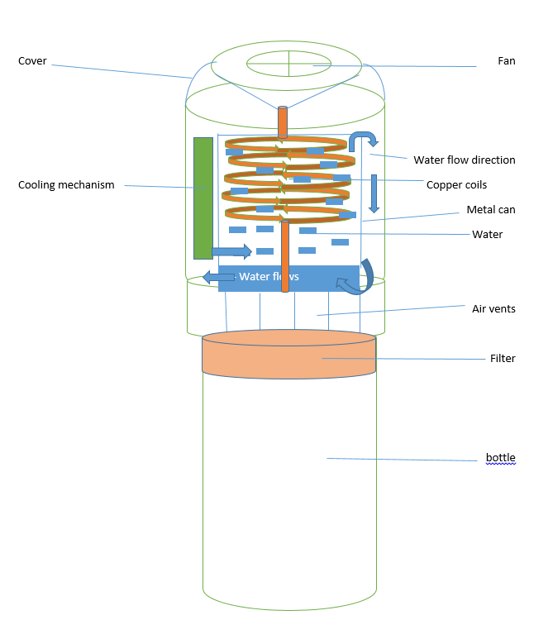
Figure 3 - Diagram of copper tubing design

General Description
A fan takes draws air in at the top of the flask. The air then gets channelled through copper tubing, cooling it down to allow moisture to accumulate on the outside of the copper pipe. The condensed water is then allowed to drip through a filter before being collected in a bottle. There are vents at the end of the tubing to allow air to escape, the vents could be removed in order to increase pressure which may promote condensation.

Cooling Mechanism
To retrieve the condensed water, the air in the copper tubing must be cooled down. The idea is to surround the copper tubing with water and have a cooling system to cool down the water. A thermostat might be included to monitor the temperature of the water. If the temperature rises above a certain temperature, a control system will then operate a pump that circulates the water to allow for periodic cooling of the water.

Cost estimation
Component(s) | Quantity | Price per unit (£)
Copper microtube | 1 | 14.99
Breadboard | 1 | 7.18
Fan 5V | 1 | 4.6
Switch | 1 | 1.3
Bottle | 1 | 1
Total | 5 | 29.07
Figure 4 – Table showing cost estimation for design 2. Note that some components, such as the cooling system, are not listed because they cannot be purchased directly online.

3.3 Comparison of both designs
Design 1 is simpler than Design 2, however, heat sinks on the cold side a Peltier might not be the most ideal way of extracting water vapour from air in terms of power efficiency.
Design 2 is quite complicated and time consuming. It is highly unlikely to be completed in time given the amount of time remaining. Furthermore, the cost of such a design could be considerably higher as a compact cooling system, copper cooling tubes and batteries that operates the circulatory system.
Therefore Design 1 is favoured over Design 2.

Budget and further cost:
So far, £51.79 has been spent purchasing components. Further costs will be on suitable sized heat sinks, water filters, batteries and circuit components. The water filter will need to be bought because of technical limitations.
After the testing all the components, total power consumption of components can be quantified. Suitable batteries can then be bought to finalize the design. A container will be built (possibly 3D printed) to fit the device. If lack of time, facilities or budget are an issue, purchasing a container online might be an option.

Discussion
This split the research into several main parts:
- Cooling and Thermoelectric Devices
- Material Selection
- Optimal Condensation Conditions
- Water Collection and Filtering

4.1 Cooling and Thermoelectric Devices
There are 3 main types of thermoelectric effects: the Seebeck, Thomson and Peltier effects.

Seebeck Effect:
The Seebeck effect works by turning heat directly into electricity. The heated surface gives electrons at the heated side of the semiconductor more energy. In the N-type region, this causes negatively charged electrons to flow towards the lower energy electrons at the cold side, creating a net flow of conventional current upwards. The same idea applies to the P-type region, causing a net current flowing downward (see figure 5).
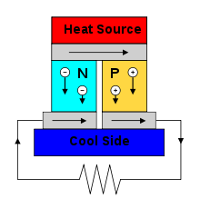
Figure 5 – Seebeck Effect (https://en.wikipedia.org/wiki/Thermoelectric_effect)

Thomson Effect
The Thomson Effect is closely related to the Seebeck effect, but only occurs in a single conducting material. For example, if cooling one end of the wire while heating up the other, electrons would flow from hot-to-cold, creating a conventional current from cold-to-hot.

Peltier Effect
The Peltier effect is the opposite of the Seebeck effect. A potential difference is applied across the two semiconductors, producing a current which causes heat to be removed from one side of the device to create the difference in electron energy levels for the current to flow (see figure 6).
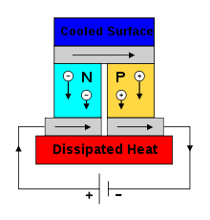
Figure 6 – Peltier Effect (https://en.wikipedia.org/wiki/Thermoelectric_effect)
After looking at the 3 main types of thermoelectric device, it became obvious that Peltier was the only choice, primarily because electricity is required to cool our heat sinks for condensation to occur. The Seebeck and Thomson methods also create a temperature difference with Steady-State condition, as opposed to an equilibrium condition created by the Peltier Effect. (Lachish, 2014) Steady-State conditions are harder to maintain in a system of our desired scale and invite more room for error in our final design. For these reasons, the Peltier effect was chosen.

4.2 Condensation
The two main conditions for condensation to occur are humid air and a cold surface for the vapour in the humid air to condense on. When the gaseous vapour in the humid air meets the cool surface, the vapour loses energy as heat to the surface, causing it to change state from gas to liquid.
To increase the rate at which the water condenses, one can either decrease the temperature of the cold surface or increase the pressure of the humid air. The former is more optimal, since the Peltier device can be run at a higher current to create colder temperatures, accelerating the water generation rate. Despite being easier, this means that the device will use much more power and will become unsuitable for battery operation.
A possible modification to balance power consumption could be to periodically pressurise a sample of air, cool it to extract the condensation, then get a new air sample. The higher pressure means a higher cool temperature can be used to achieve the same effect as in an unpressurised environment.

4.3 Water collection methods:
Over time, condensation will build up on the heat sink attached to the cool side of the Peltier module. Thus, a way to effectively remove and collect the water droplets is required.
The simplest method is by using gravity. As small water droplets merge, forming larger droplets, the weight of the droplet will eventually overcome the static friction between the water and the surface. The droplet will then drip down through the filter and into the container.
A flat cooling surface will take a long time to gather enough condensation to form drip as the water beads will struggle to coalesce. Therefore, by introducing a circular cone heat sink or tapered surface, gathering water droplets will be much faster as the shape will encourage large droplets to form at the tip. Moreover, this will increase the surface area in contact with humid vapours and therefore increase the rate of water condensation.

4.4 Water purity and possible contamination from metals
One of the main concerns is the purity and quality of the generated water.
Materials used in the heat sinks may be contaminating the water, making it potentially dangerous to drink.
The basic idea was to run the generated water through a standard BRITA filter or similar, which can remove chlorine and heavy metals. The hope is that the filter will be able to remove any impurities from the heat sink to make it safe to drink.
In preliminary tests, Aluminium heat sinks have been used.
In general, Aluminium's corrosion resistance is very good. This is due to the thin oxide layer formed on the surface that prevents further oxidation. Unlike the oxide layers on many other metals, it adheres strongly to the parent metal, meaning even if it is damaged mechanically the oxide layer can repair itself almost immediately. When in contact with water, the presence of chlorides and heavy metals has the greatest effect on Aluminium's durability. Furthermore, the rate of corrosion increases when the material is wet for long periods of time. Since the possibility of aluminium contaminating the drinking water exists, the effect of aluminium on health must be considered, since if there are no health risks then this topic of discussion can be safely ignored.

4.5 Does aluminium affect general health?
Whilst there is no proof suggesting that the natural traces of Aluminium found in foods or beverages are harmful, several investigators have reported that long-term exposures to high levels of Aluminium in drinking water could result in the clinical diagnoses of dementia. The European Union set a guideline limit of 200µg/litre (Aluminium in Drinking Water, (no date)). If possible, our generated water will be tested to ensure compliance with this standard.
In the case where our water is contaminated, the Aluminium heat sinks can be replaced with Ceramic ones. Ceramic heat sinks are more resistant to corrosion than most metals and alloys and are also generally cheaper than Aluminium ones; however, they generally have a lower thermal resistance.

Progress to Date
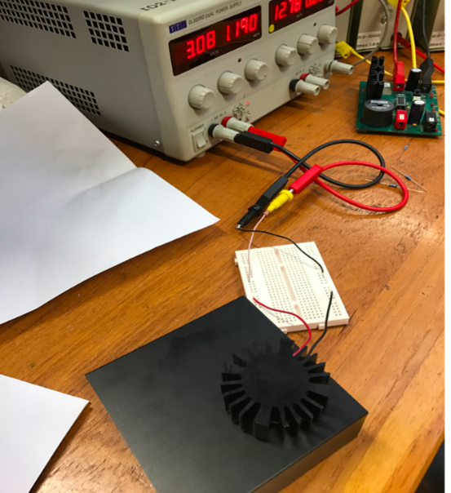
Figure 7 - Photo of Test circuit
A simple test was set up on 27th January. The purpose of this test was to investigate how the Peltier module works and the method to implement it in the circuit. The reason for using DC voltage supply instead of the batteries as designed was that applied voltage could be changed arbitrarily (within limitations) through direct connection to the power supply. Thus, it is easier to observe the influence of voltage and current on the Peltier module. During the experiment, one investigation was that the higher voltage and current across the module was, the quicker heat was generated, which was in accordance with theory.
One main problem was that the heating process was quite slow (relative temperature was measured with physical contact), which would be worse since batteries would be used for practical purposes. Therefore, the process might be slower. It was previously discussed and determined that heat sinks of smaller sizes would be required for future work and batteries with higher voltages and current were indispensable to guarantee speed of process. Another problem was how to adhere components together. A metal oxide thermal compound was found on RS which had high thermal conductivity and high insulation resistance.

Test results
Condensed water can be observed on heat sink.
Cooling effect: the heat sink for cooling reached -4 degree Celsius as the lowest value.
Heat dissipation: the heat sink for dissipating heat go to 32 degree when relatively high current and voltage applied.
Power budget for Peltier module$: V_{max} = 7.8V$ $I_{max} = 3.9A$, therefore the maximum working power is P_{max} = $V_{max}*I_{max}=7.8*3.9=30.42W$. The module works properly and efficiently at the current at 1.7A and a voltage of 3.0V, therefore the module will draw$5.1W$ of power from batteries.

Future work
Further tests need to be conducted to investigate the efficiency of water collection and battery powered method. Ideally, the device can generate the full 0.5 litres within a sensible amount of time. In the next several weeks, there will be more experiments on the cooling as well as the water collecting device.
Experiments using batteries as a power supply instead of the power supply unit should be conducted. Furthermore, the filter process will need to be analysed carefully to ensure the drinkability of the generated water.
Once a proof of concept prototype is complete and operational, downsizing will be the focus.

References

- Lachish, U. (2014) 1   Thermoelectric Effect Peltier Seebeck and Thomson. Available at: http://urila.tripod.com/Thermoelectric.pdf (Accessed: 4 February 2017).
- How thermoelectric TEG generators work - thermoelectric generator (2015) Available at: http://thermoelectric-generator.com/how-thermoelectric-teg-generators-work/ (Accessed: 29 January 2017).
- Metals - specific heats (no date) Available at: http://www.engineeringtoolbox.com/specific-heat-metals-d_152.html (Accessed: 27 January 2017).
- Corrosion resistant ceramics (2017) Available at: http://www.dynacer.com/properties/corrosion-resistance/ (Accessed: 2 February 2017).
- Aluminium in Drinking Water (no date) Available at: https://www.dhs.wisconsin.gov/publications/p0/p00261.pdf (Accessed: 2 February 2017).
- Aluminium corrosion resistance (2016) Available at: http://www.aluminiumdesign.net/design-support/aluminium-corrosion-resistance/ (Accessed: 2 February 2017).
- Mohankumar, D. (no date) Temperature controlled DC fan. Available at: http://www.electroschematics.com/4788/temperature-controlled-dc-fan/ (Accessed: 2 February 2017)
- What are the drinking water standards? (2010) Available at: http://dwi.defra.gov.uk/consumers/advice-leaflets/standards.pdf (Accessed: 3 February 2017).
- Water distribution on Earth (2016) Available at https://water.usgs.gov/edu/earthwherewater.html (Accessed: 8th Frebruary 2017)
- Waterborne Diseases (2014) Available at http://www.vestergaard.com/global-challenges/waterborne-diseases (Accessed 8th Feb 2017)

Appendix
- Summary of research on existing products
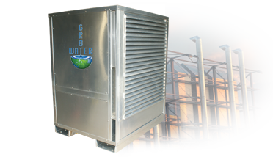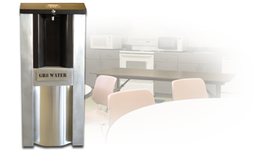
Figure 1. Commercial AWG Figure 2. Residential AWG
AWG stands for atmospheric water generator
(http://www.gr8water.net/products/atmospheric-water-generators)
Main features:
- Large- scale solution to water shortage problem
- The water is filtered using a special ozonation process and UV (ultra violet) filtration to remove any impurities such as microorganisms (bacteria, germs and viruses) up to .01 microns.
- The cost of such AWGs are above 2,000 dollars which are not affordable to the public.

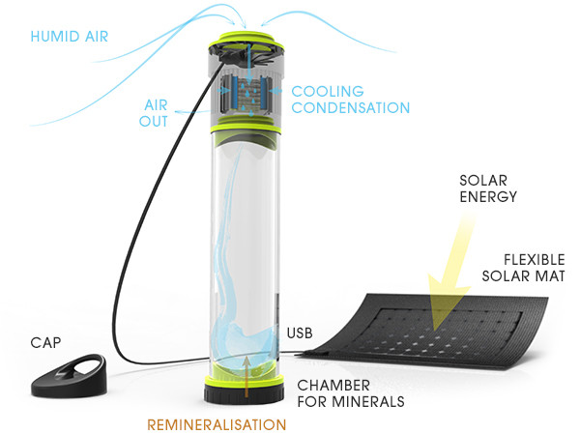
Figure 3. FONTUS-AIRO
(https://uniquehunters.com/fontus-airo-self-filling-water-bottle-harvests-water-thin-air/)
Main features:
- A fan is used to draw the ambient air and then passes water through a filter, followed by a condensing process.
- A process of re-mineralization is set up at the bottom of bottle to add vitamins and minerals to produce fresh mineral water by using water soluble small capsules.
- It needs to be charged by using solar energy or component connected to bike.
- The price of Fontus-airo is above 800 dollars, which is not cost-friendly to the public.
2. Fan Circuit
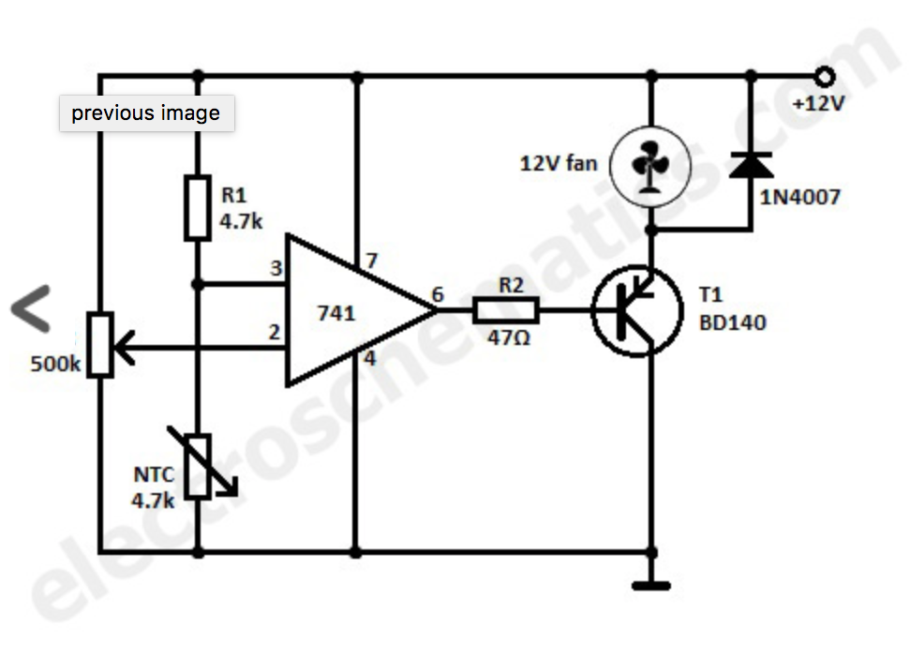
Reference for temperature control circuit
Mohankumar, D. (Accessed 2 February 2017)

3. Diagram displaying the relationship between Temperature and Heat
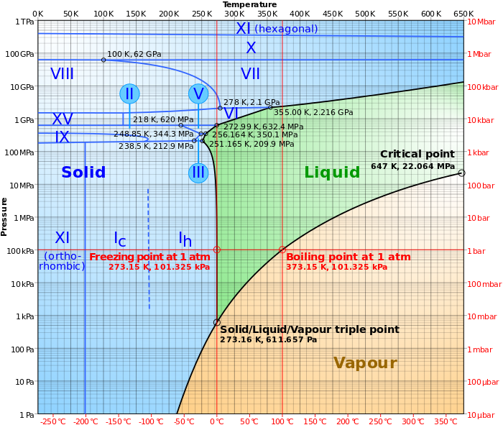https://en.wikipedia.org/wiki/File:Phase_diagram_of_water.svg

4) System Block Diagram
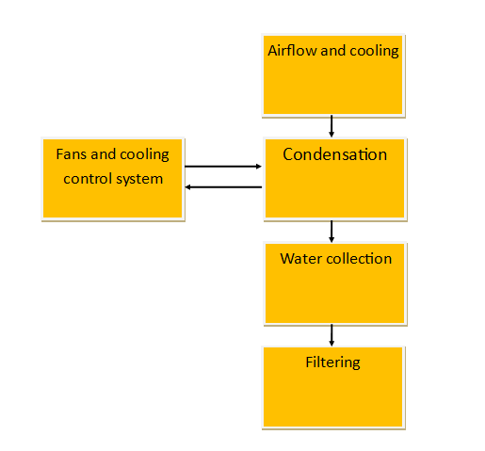

Weekly meetings:

Week 2: 13:00
Attend member: Lillian, Mike, Eric, Shaun, Nick, Greg
Absent member: Tom (Interview)
Decide lists of component and check the specifications
Specify the structure of the cooling device, discussion of heat sink and filter
Test of each single component taking place next week
Shaun upload Gantt chart, project spec, etc.

Week 3: 13:05

Attend member: Mike, Eric, Shaun, Nick, Greg, Tom, Lillian
Test the components received, including heat sink, breadboard, Peltier module (cooling)
Cooling device and heat sink operational; require infrared thermometer.

Week 4: 13:05
Attend member: Mike, Eric, Shaun, Nick, Greg, Tom, Lillian
Test the behaviour of the glue, fan and the power consumption of the Peltier. Design the container of the device.
Test result:
Heat sink Glue: Worked properly; it can be washed by water.

